|  |  |
| --- | --- |
|  | **FPT ACADEMY INTERNATIONAL**  **FPT – APTECH COMPUTER EDUCATION** |

Centre Name: ACE-HCMC-2-FPT.

Address: 590 Cach Mang Thang 8, District 3, Ho Chi Minh City, Viet Nam.

BGV ACADEMY

|  |  |  |
| --- | --- | --- |
| **Supervisor** | PHAM THI LANH | |
| **Semester** | 1 | |
| **Batch No** | T1.2008.M0 | |
| **Group No** | 2 | |
| **Order** | **Full name** | **Roll No.** |
| 1. | Phùng Hoài Bảo | Student1273009 |
| 2. | Nguyễn Thế Vinh | Student1273003 |
| 3. | Ngô Ngọc Hoàng Giang | Student1272818 |

Month 10 Year 2020



2

This is to certify that

Mr: Phung Hoai Bao

Mr: Nguyen The Vinh

Mr: Ngo Ngoc Hoang Giang

Has successfully Designed & Developed

**BGV ACADEMY**

Submitted by:

Pham Thi Lanh

Date of issue:

Authorized Signature:

Table of Contents

REVIEW 1 6

REQUIREMENT SPECIFICATION 7

CUSTOMERS REQUIREMENT SPECIFICATIONS (CRS) 8

1. Client: BGV Academy 8

2. Business/Project Objectives: 8

3. Inputs provided by clients: 8

4. Hardware Requirement: 8

5. Software Requirements: 8

ARCHITECTURE & DESIGN OF THE SYSTEM 9

SITEMAP 10

WEBSITE LAYOUTS 11

1. Homepage: 11

2. Informative pages: 13

TASK SHEET 1 14

REVIEW 2 15

WEBSITE INTERFACE 16

1. HOMEPAGE 16

2. ABOUT : 19

3. TEACHER 20

5. BLOG : 25

6. Contact page 26

7. Footer 26

8. Login/Sign up 27

TASK SHEET 2 29

CHECKLIST VALIDATION 31

ACKNOWLEDGEMENT

I would like to acknowledge all those who have given moral support and helped in making the project a success.

I wish to express my gratitude to the e-Projects Team at the Head Office, who guided and helped me. I would also like to express my gratitude to all the staff members of my center for not only providing me with the opportunity to work with them on this project, but also for their support and encouragement throughout the process.

I also express my sincere gratitude to the e-Projects Team at the Aptech Head Office and my project guide at the organization, for her valuable guidance and support for the completion of this project.

And finally, I would like to offer many thanks to all my colleagues for their valuable suggestions and constructive feedback.

SYNOPSIS

Academy BGV is into business for more than a decade. They have been advertising about their coaching classes through newspapers, pamphlets, television.Now with changing times, they have decided to go online as most of the students today are frequent users of Internet. They have planned for a website with complete details about the Coaching classes.

The website is to be developed for the Windows Platform using HTML5, JavaScriptand Geolocation. The site should work well in all leading browsers including Chrome,IE, Firefox etc.

# REVIEW 1

## REQUIREMENT SPECIFICATION

The Web site is to be created based on the following requirements:

1) The Home Page should have suitable logo, and decent colour combination.

2) Information should be neatly placed at suitable location.

3) Various pages having information about different courses/subjects taught at the classes, Faculty/Teachers complete information and previous year’s success stories should be listed.

4) The site should display a menu which will contain the options for brief introduction about the above mentioned information, location/address of the coaching classes and any other information if required.

5) The information should be categorized according to different subjects like if a User wants to see details of ‘Commerce’ then he click on a Link/button/menu etc and he will see details of course structure of commerce. Similarly for ‘Mathematic’, ‘Languages’ and other subjects.

6) When a user selects any course stream, complete list of subjects for that course stream will be displayed.

7) Details of the courses should be displayed on the Web Page along with the title and it should be stored in Individual Word documents which can be downloaded or viewed by the User who wishes to see the same.

8) Price List for all courses should be available for download.

9) There should be a “Contact Us” page which will have the Address of the Coaching Classes and the mail address which when clicked will invoke the local mail client from where they can send an email. Address of the Academy should be displayed using GeoLocation API (eg. GoogleMaps).

## CUSTOMERS REQUIREMENT SPECIFICATIONS (CRS)

### Client: BGV Academy

### Business/Project Objectives:

* Provide a website to display hospital programs and services such as: “About us”, “Course”, “Admissions”, “Blog”, “Contact Us'",...
* Allow customers to see what events they want. Interacting with us is easier.

### Inputs provided by clients:

Inputs to the existing system.

Outputs from the existing system.

Process involved in the application.

Expected delivery dates.

List of deliverables.

### Hardware Requirement:

* A minimum computer system that will help you access all the tools in the courses is a Pentium 166 or better
* 64 Megabytes of RAM or better

### Software Requirements:

* Notepad/HTML editor
* Dreamweaver
* IE 5.0/ Netscape 6.0

## ARCHITECTURE & DESIGN OF THE SYSTEM

CLIENT



SERVER



Font End technologies

(HTML5, CSS3, Bootstrap, jQuery)

## SITEMAP

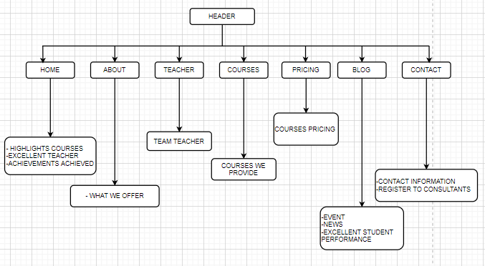

## WEBSITE LAYOUTS

Here are our layouts which will show you how we brainstormed ideas for the academy’s web pages.

The website is going to have several pages which include different information in the same main layout.

### Homepage:

This layout below describes how we created our Homepage which contain three important parts:

* *Page-header and Navigation bar:*

Page-header: We will have our name, address, mail and phone number to contact with us.

Navigation bar: One of the most crucial sections in the whole website which will indicate people how they interact with us. It provided the logo, some information like Homepage, About us, Teachers, Courses, Pricing, Blog and Contact. Each section will have details.

* *Content:*

This part is customized belong to the title of the individual websites, especially Homepage with a little information of each section in the navigation bar.

* *Footer:*

The final part of all our websites is definitely Footer which will reveal some convenient ways to contact the Academy in different social channels like Email, Facebook, Twitter, …

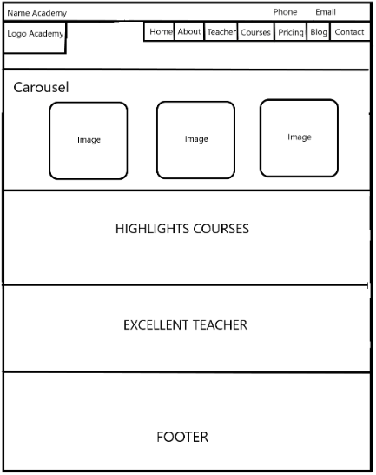

### Informative pages:

This layout we will apply for most of other pages (Teachers, Courses, Pricing, ...) which provide people the easiest way to know more about the academy. It also has the same Page-header, Navigation bar and Footer as Homepage, but the main content is changed. Interestingly, we will design with all pictures and a little information so that people can understand what they’re about to click in and enter another related website easier.

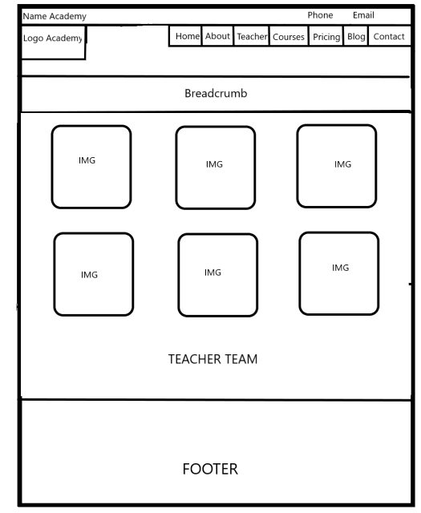

## TASK SHEET 1

|  |  |  |  |  |  |  |
| --- | --- | --- | --- | --- | --- | --- |
| **Project Ref. No.** | **Project Title** | **Activity Plan Prepared**  **by** | **Date of Preparation of Activity Plan** | | | |
| **Task** | **Actual Start Date** | **Actual Days** | **Teammate Names** | **Status** |
| Create layouts for website base on group discussion  ideas | BGV Accademy | Bao | 14/10/2020 | 14/10/2020 | Bao | Completed |
| Draw layouts using  Paint | BGV Accademy | Bao | 16/10/2020 | 18/10/2020 | Bao | Completed |
| Write project  report 1 | BGV Accademy | Bao | 16/10/2018 | 18/10/2020 | Giang | Completed |
| Homepage design and coding (include navigation bar and footer) | BGV Accademy | Bao | 16/10/2018 | 19/10/2020 | Vinh | Completed |

# REVIEW 2

## WEBSITE INTERFACE

1. **HOMEPAGE**

When the user visits the website, the first thing the user sees is the homepage of the site and this is the introduction and commitment page of BGV Academy.

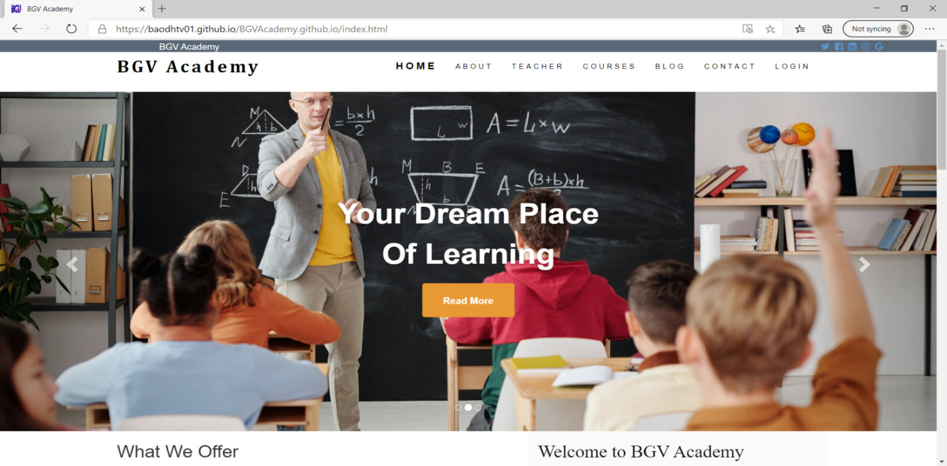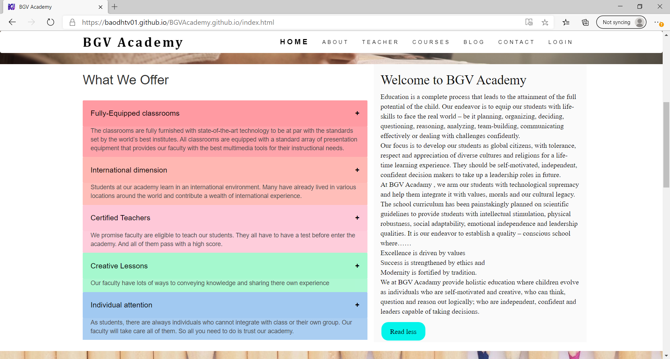

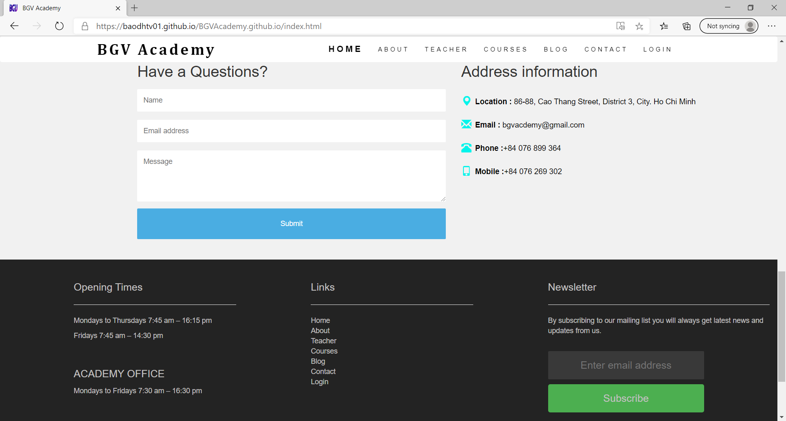

|  |  |
| --- | --- |
| **Title** | **Description** |
| Twitter  Facebook  Instagram  Google | * Show account login by social networks. * Feedback, Query where people can leave their comments. |
| Home | - Introduction and formation of BGV  - When customers click on the sidebar "WHAT WE OFFER", a detailed introduction about the classes as well as the quality of teachers' teaching will appear.  - Display graph of experience and the number of course subscribers.  - Display questionnaires and parents can comment or register courses for children.  - Displays contact information and address of the company, business hours. |
| About | * A detailed introduction and history of BGV's formation and parent commitment to the courses. * Comments of parents when registering for the child about the course in BGV. |
| Teacher | Detailed introduction about the teachers teaching courses at BGV schools (details about what subject the teacher teaches, the teacher's experience) |
| Course | - Detailed introduction of courses and lessons :  + Time  + Lession  + Pricing  - Register the course. |
| Blog | - Essential information for children and parents about life knowledge and how to teach children. |
| Contact | - Contact us by address, phone number, email, website.  - Show up on website. |
| Login | - Customers can login to create an account  - Accounts can be linked via social networks such as Facebook, Twitter, Gmail Google.  - If a customer forgets his password, he / she can easily retrieve it. |

1. **ABOUT :**

- When you click to “ about ” next to Home , this page will display introductory details about BGV.

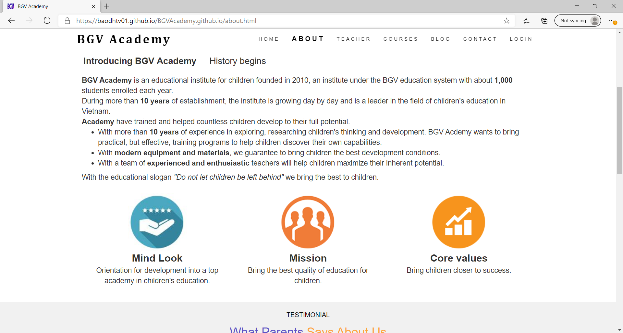

- When you click to “ History Begins ” next to “ Introducing BGV Academy ” , this page will show the BGV field development and show a chart of the BGV formation history.

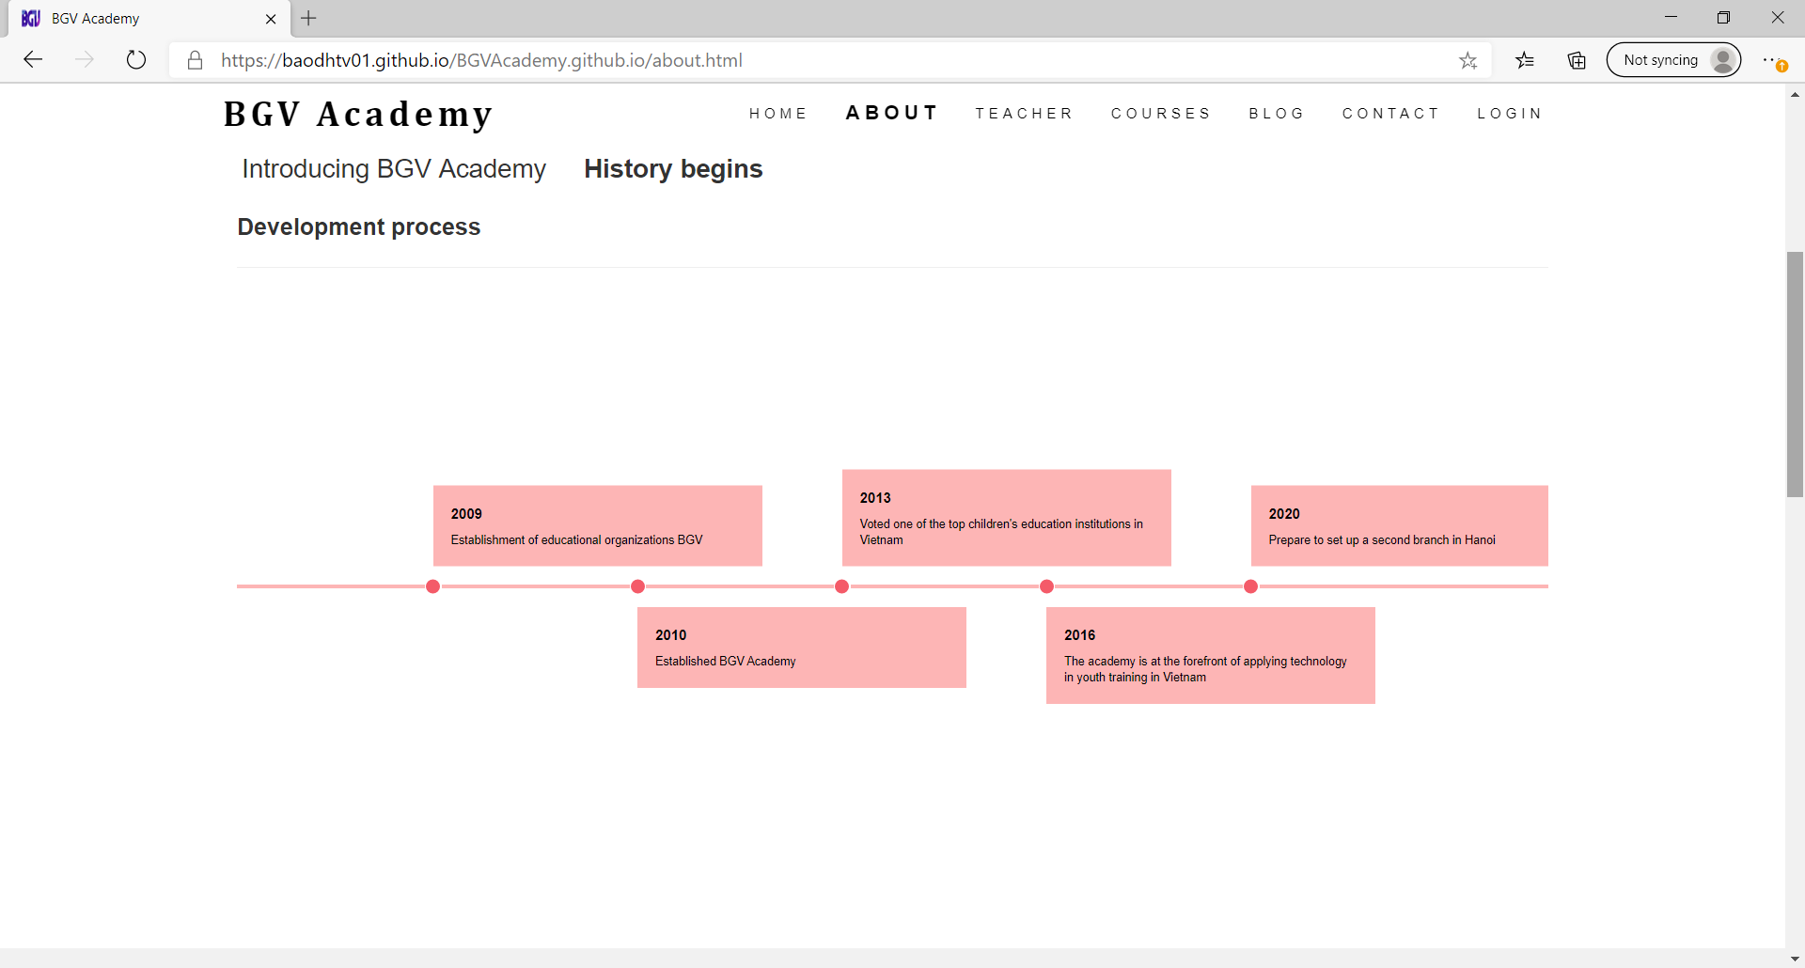

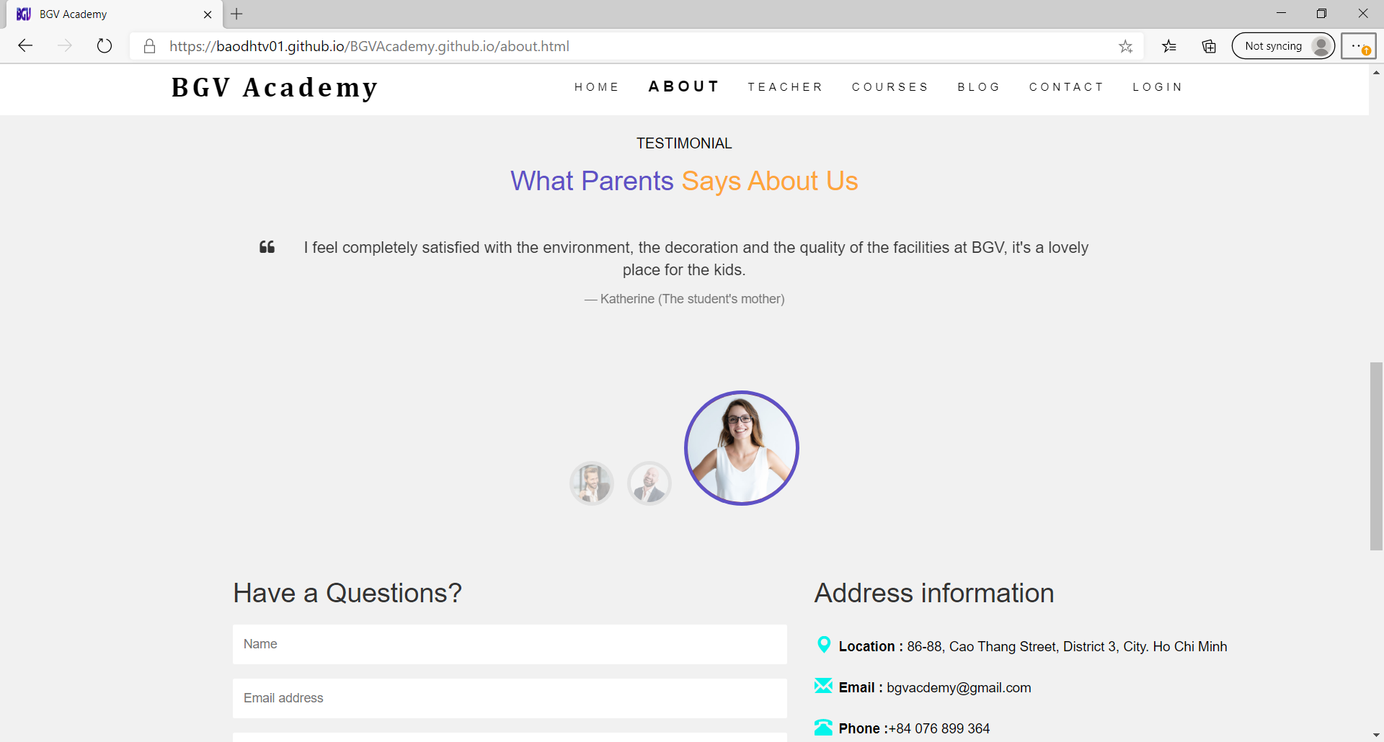 - When you scroll down, you will see parent comments and comments when your child participates in our courses and every time you click on any teacher , all the details about that teacher will be displayed.

1. **TEACHER**

- When you click on "Teacher", this page will show all teachers of the BGV school. Each teacher teaches his / her forte and the teacher's thinking about education so that parents can choose the right teacher for their child's course and when you click

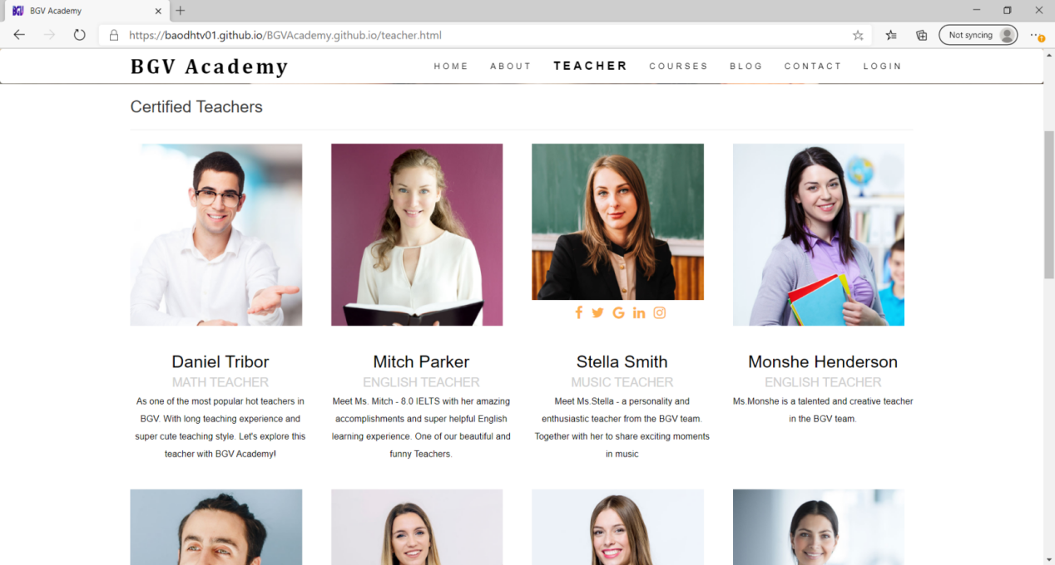

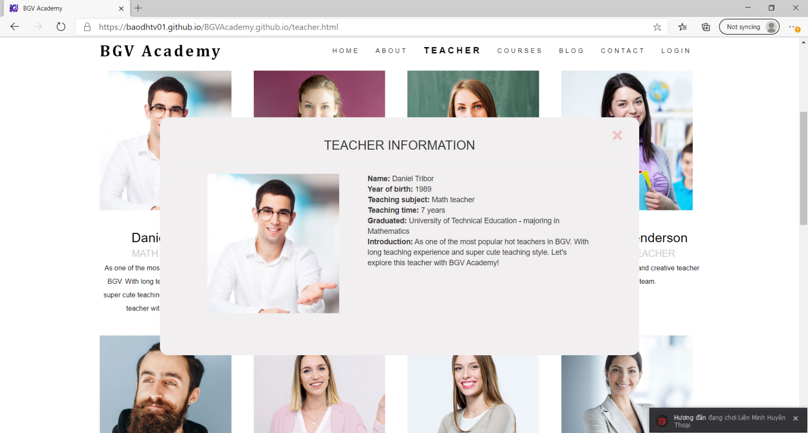

1. **COURSES :**

**-** Clicking on "Course" displays the class and the duration of the courses.

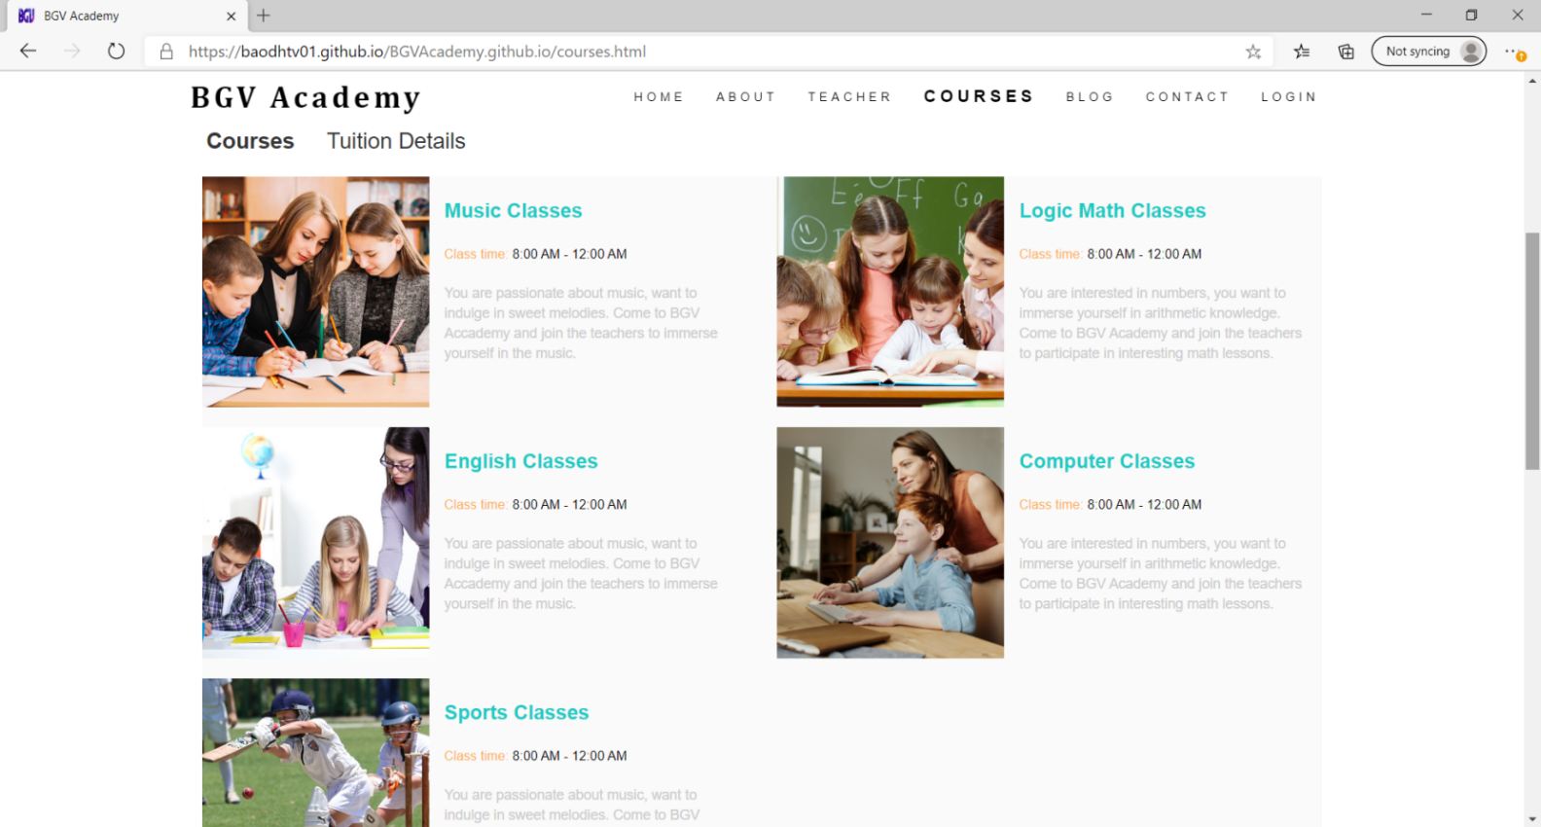

- When you click any on a course it will show the details of the introduction, the specific time, the content of the class and the tuition fee and here is an example of a music course:

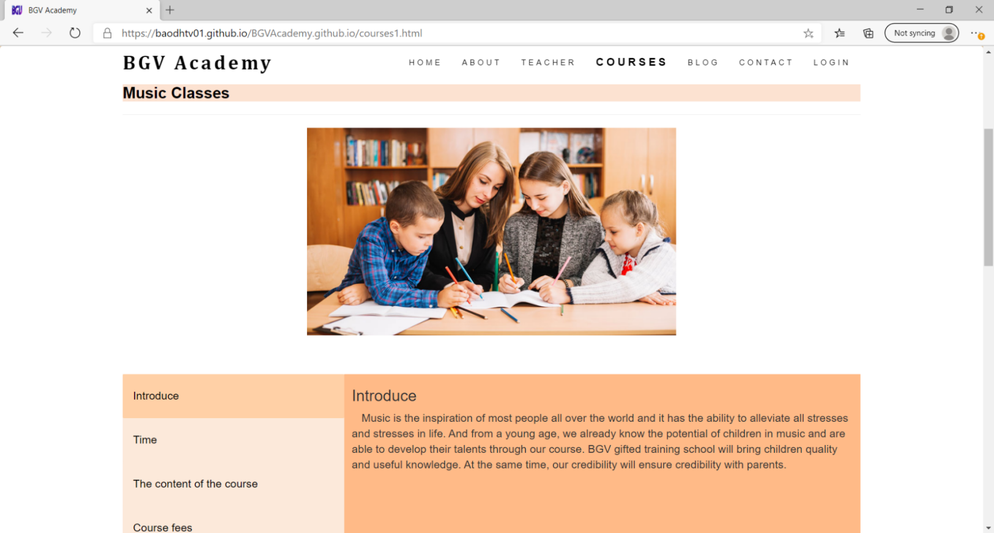

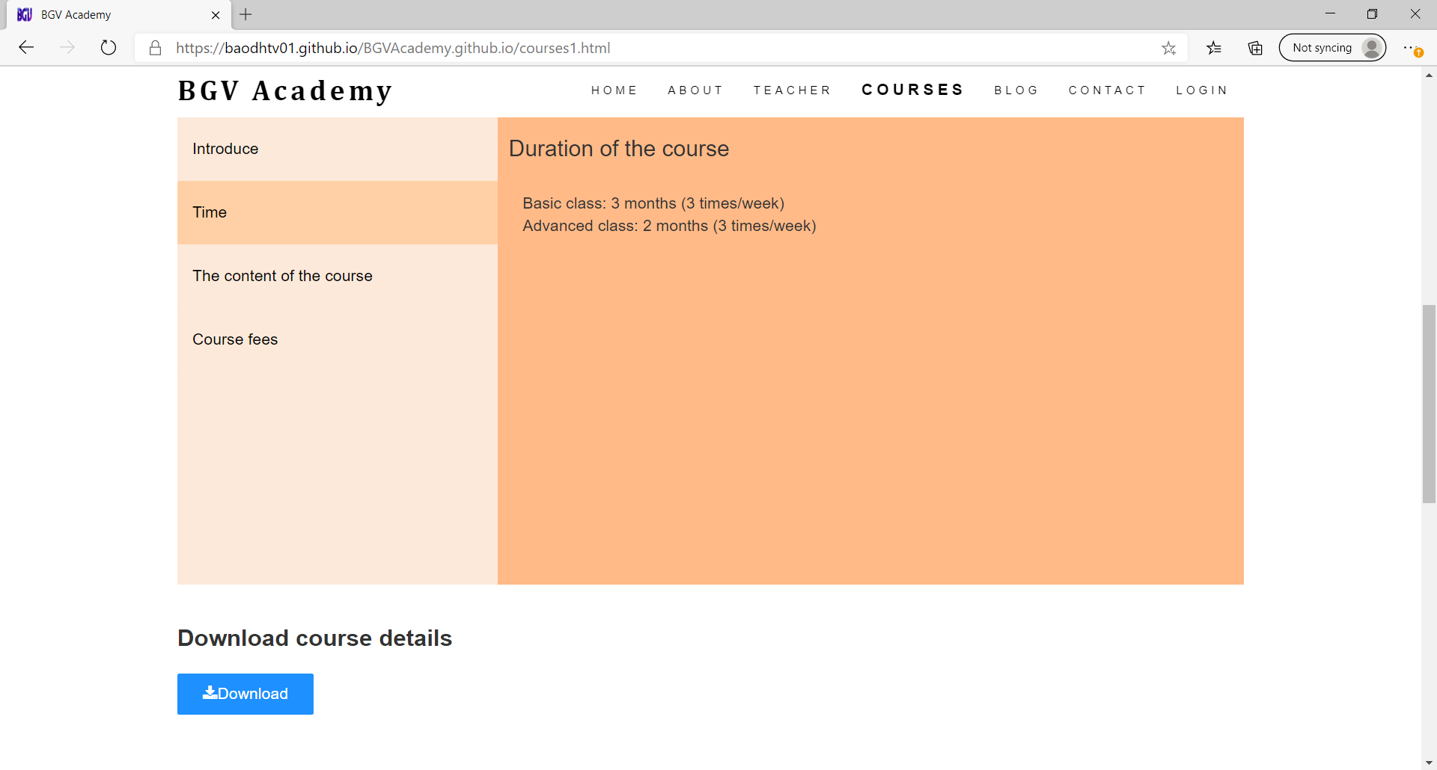

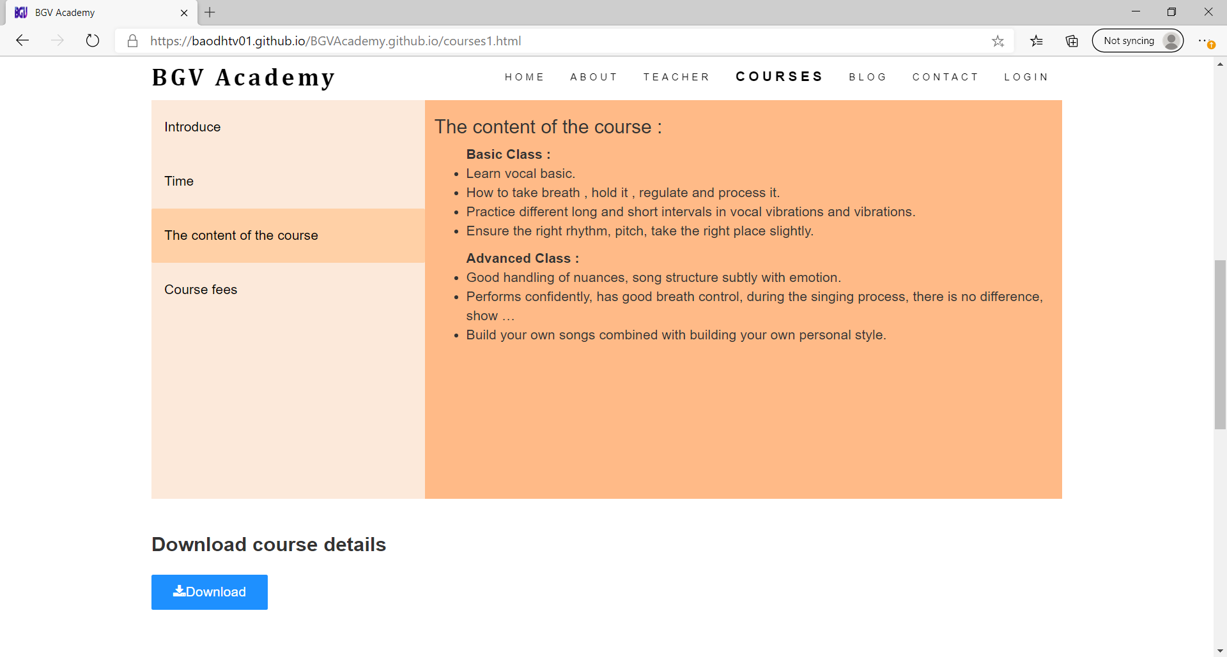

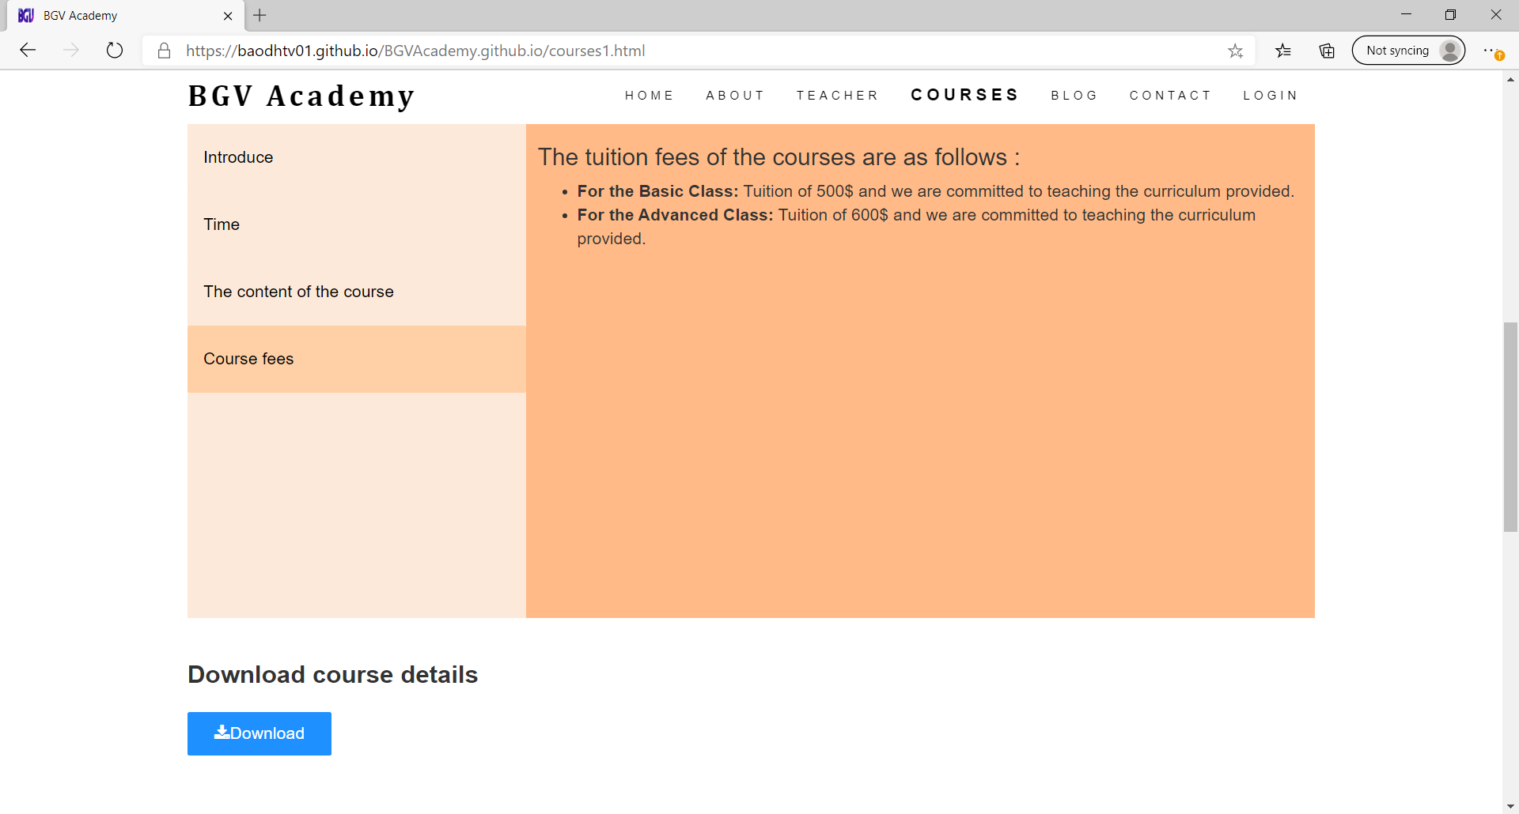- There is also a registration form and download a file which shows all the prices as well as the lessons :

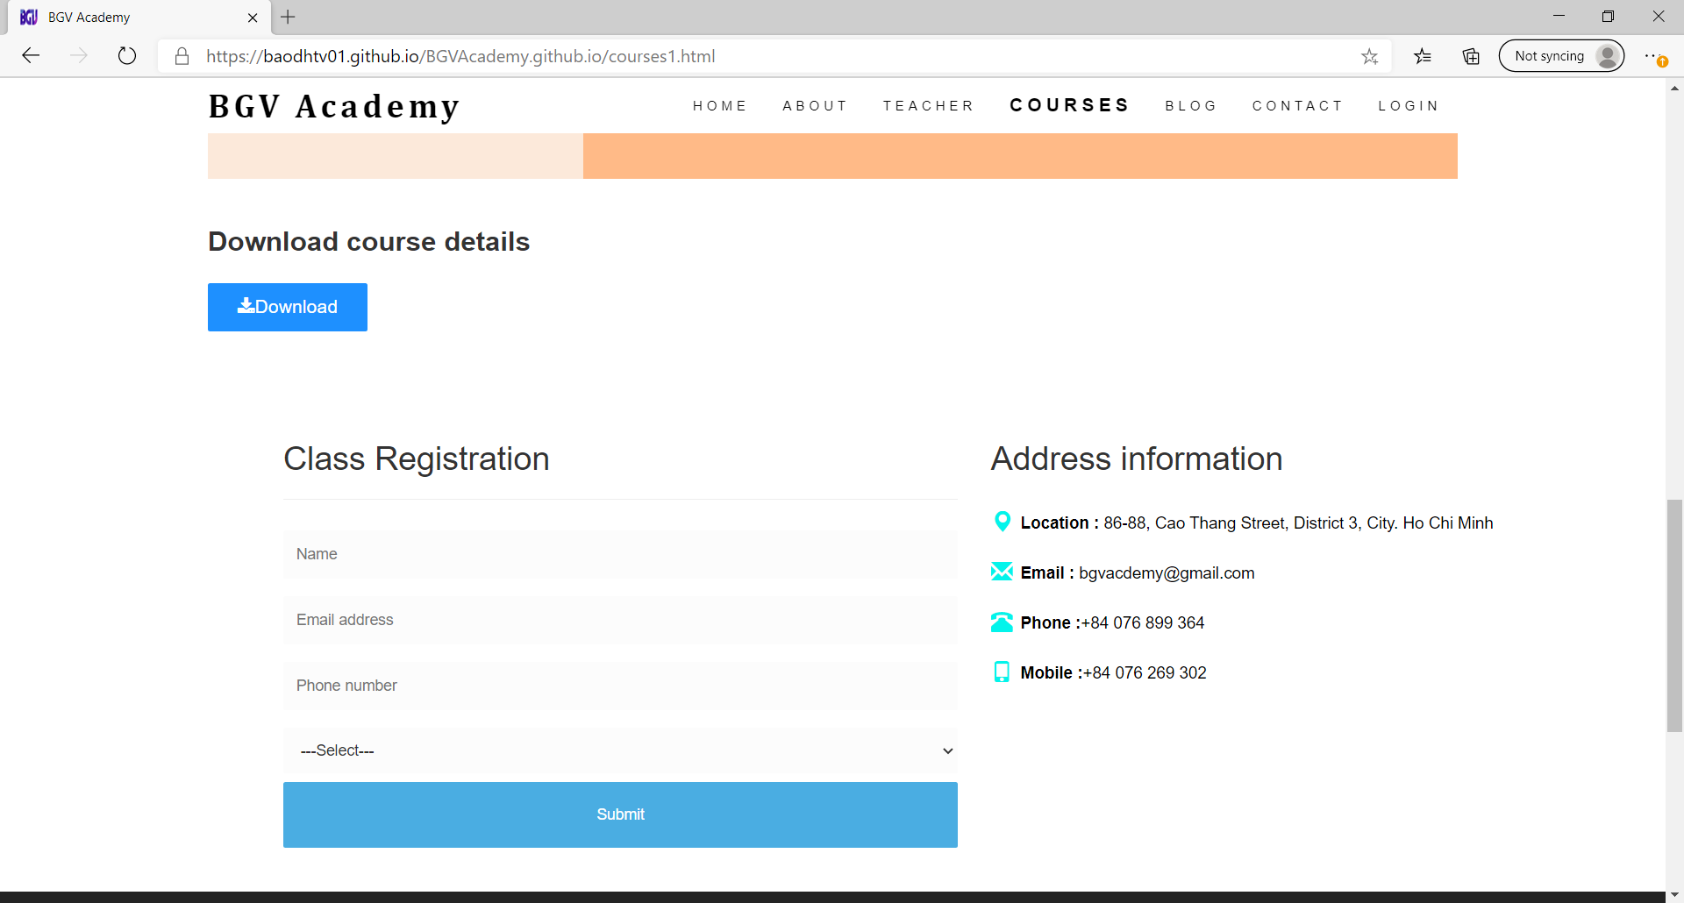

1. **BLOG :**

- When we’re Clicking on the Blog page will display articles that we have prepared to popularize knowledge for children and parents:

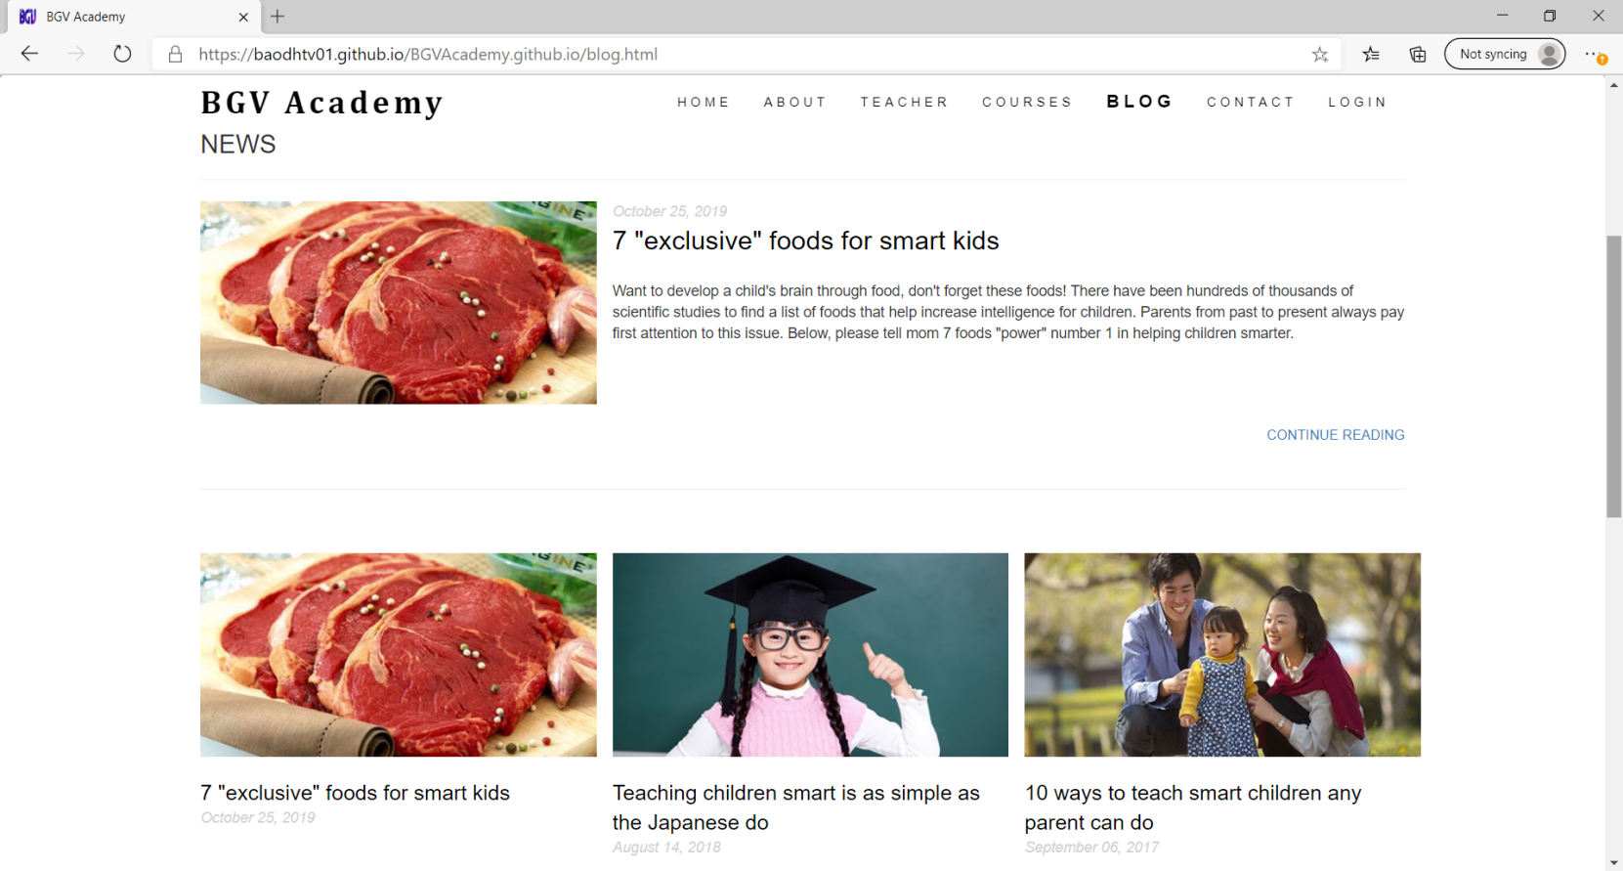**-** Then click on any title on the Blog page, the page will display details as follows: `

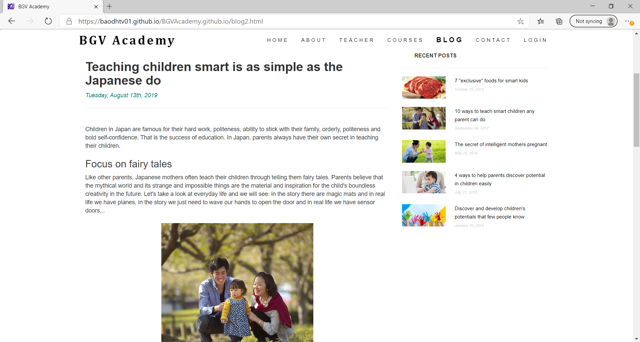

### Contact page

When you click to Contact Us in the website, this page below will show you map to the hospital with Geolocation API and main contact information. 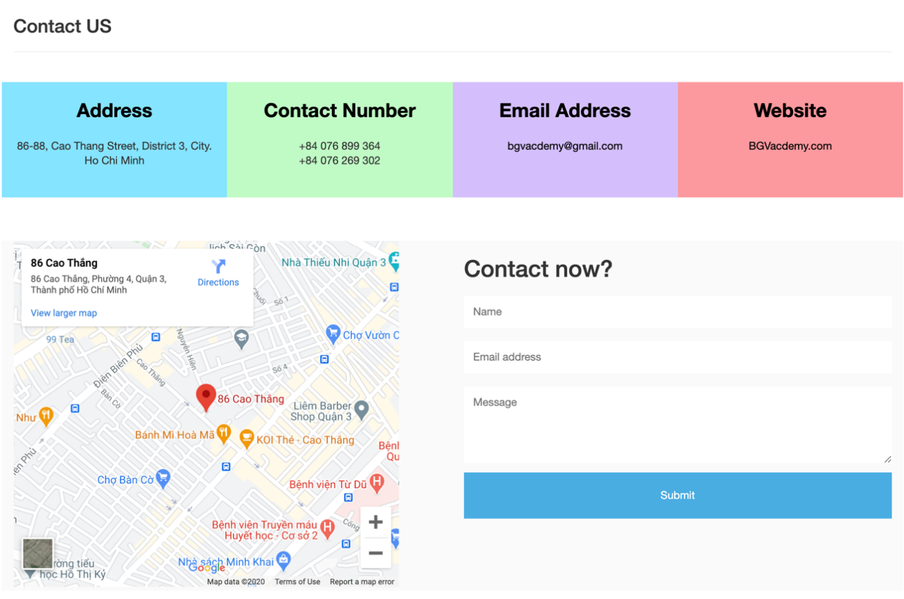

### Footer

### 

The footer has some contact times and a lot of way to contact with our academy. You can enter your email to receive our latest news and updates.

When entering your email address

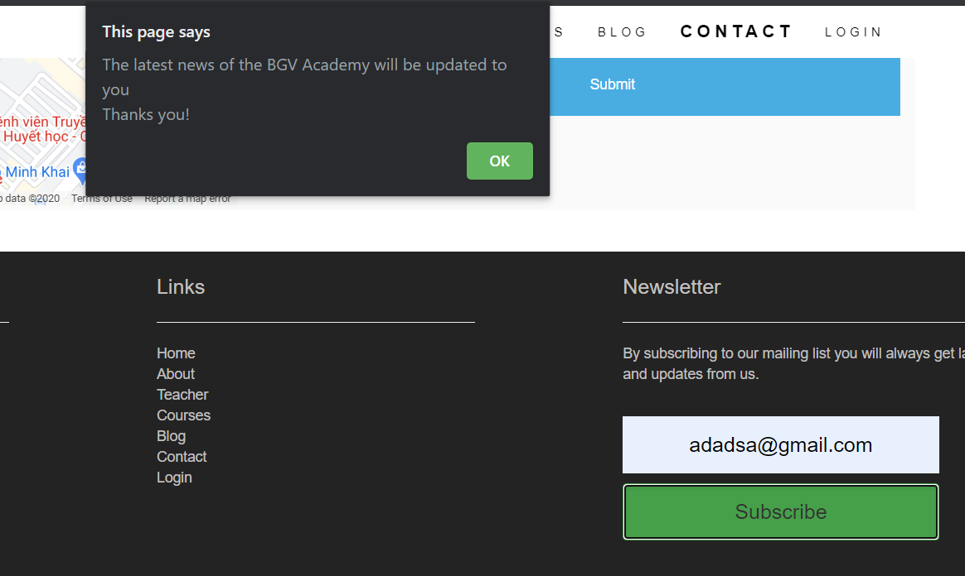

### Login/Sign up

This is the login interface

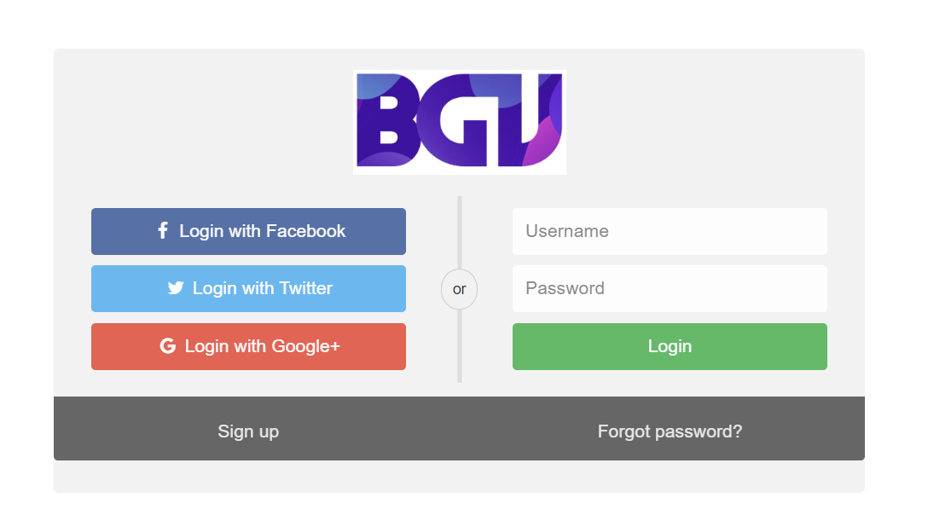

When sign up in it will return to the home page

This is the login interface

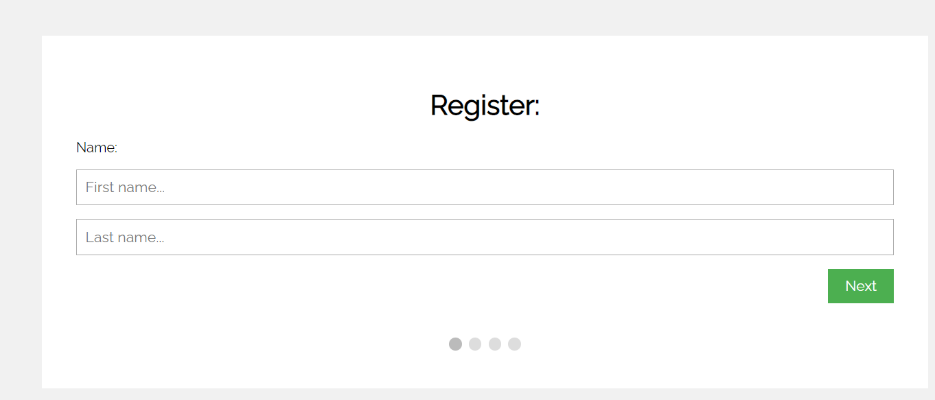

## TASK SHEET 2

|  |  |  |  |  |  |  |  |
| --- | --- | --- | --- | --- | --- | --- | --- |
| **Project Ref. No.** | | **Project Title** | **Activity Plan Prepared**  **by** | **Date of Preparation of Activity Plan** | | | |
| **Sr. No** | **Task** | **Actual Start Date** | **Actual Days** | **Team**  **mate Names** | **Status** |
| 1 | Find course information | BGV Acdemy | Bao | 15/10/2020 | 2 | Vinh | 70% |
| 2 | Find blog | BGV Acdemy | Bao | 15/10/2020 | 2 | Giang | 80% |
| 3 | Design Home page and coding | BGV Acdemy | Bao | 15/10/2020 | 7 | Bao | Completed |
| 4 | Design Teacher page and coding | BGV Acdemy | Bao | 15/10/2020 | 7 | Bao | Completed |
| 5 | Design About page and coding | BGV Acdemy | Bao | 15/10/2020 | 7 | Bao | Completed |
| 6 | Design Couses page and coding | BGV Acdemy | Bao | 18/10/2020 | 7 | Vinh | 80% |
| 7 | Design Blog page and coding | BGV Acdemy | Bao | 18/10/2020 | 7 | Giang | 90% |
| 8 | Write review 2 | BGV Acdemy | Bao | 18/10/2020 | 7 | Giang,  Vinh | 90% |

**The level of work completion assigned**

|  |  |  |
| --- | --- | --- |
| Bao | Giang | Vinh |
| 100% | 80% | 75% |

|  |  |
| --- | --- |
| Signature of Faculty | Signature of Leader Team |
|  |  |

## CHECKLIST VALIDATION

|  |  |  |
| --- | --- | --- |
| **Task No.** | **Requirement** | **Validation** |
| 1 | The Home Page should have suitable logo, and decent colour combination. | Yes |
| 2 | Information should be neatly placed at suitable location. | Yes |
| 3 | Various pages having information about different courses/subjects taught at the classes, Faculty/Teachers complete information and previous year’s success stories should be listed. | Yes |
| 4 | The site should display a menu which will contain the options for brief introduction about the above mentioned information, location/address of the coaching classes and any other information if required. | Yes |
| 5 | The information should be categorized according to different subjects like if a User wants to see details of ‘Commerce’ then he click on a Link/button/menu etc and he will see details of course structure of commerce. Similarly for ‘Mathematic’, ‘Languages’ and other subjects. | Yes |
| 6 | When a user selects any course stream, complete list of subjects for that course stream will be displayed. | Yes |
| 7 | Details of the courses should be displayed on the Web Page along with the title and it should be stored in Individual Word documents which can be downloaded or viewed by the User who wishes to see the same. | Yes |
| 8 | Price List for all courses should be available for download. |  |
| 9 | There should be a “Contact Us” page which will have the Address of the Coaching Classes and the mail address which when clicked will invoke the local mail client from where they can send an email. Address of the Academy should be displayed using GeoLocation API (eg. GoogleMaps) | Yes |